

LAB REPORT

|  |
| --- |
| 01 |

CSE416: Web Engineering Lab

Submitted To

Md. Ashraful Islam Talukder

Lecturer

Department of CSE

Daffodil International University

Submitted By

Student ID: 221-15-5606

Student Name: Mahmudul Hasan Piash

Section: 61_D1

Department of CSE

Daffodil International University

Date of Assignment Distribution: 15th June,2025

Date of Assignment Submission: 15th June, 2025

|  |  |
| --- | --- |
| Experiment No: 01 | **Experiment Name:** Design and implement a static web page using HTML and CSS |

Obtained Output:

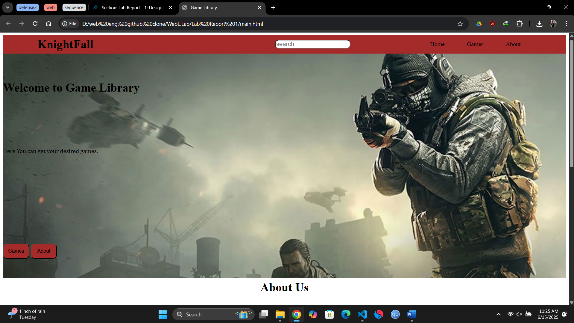

**Main.html**

**Style.css**

